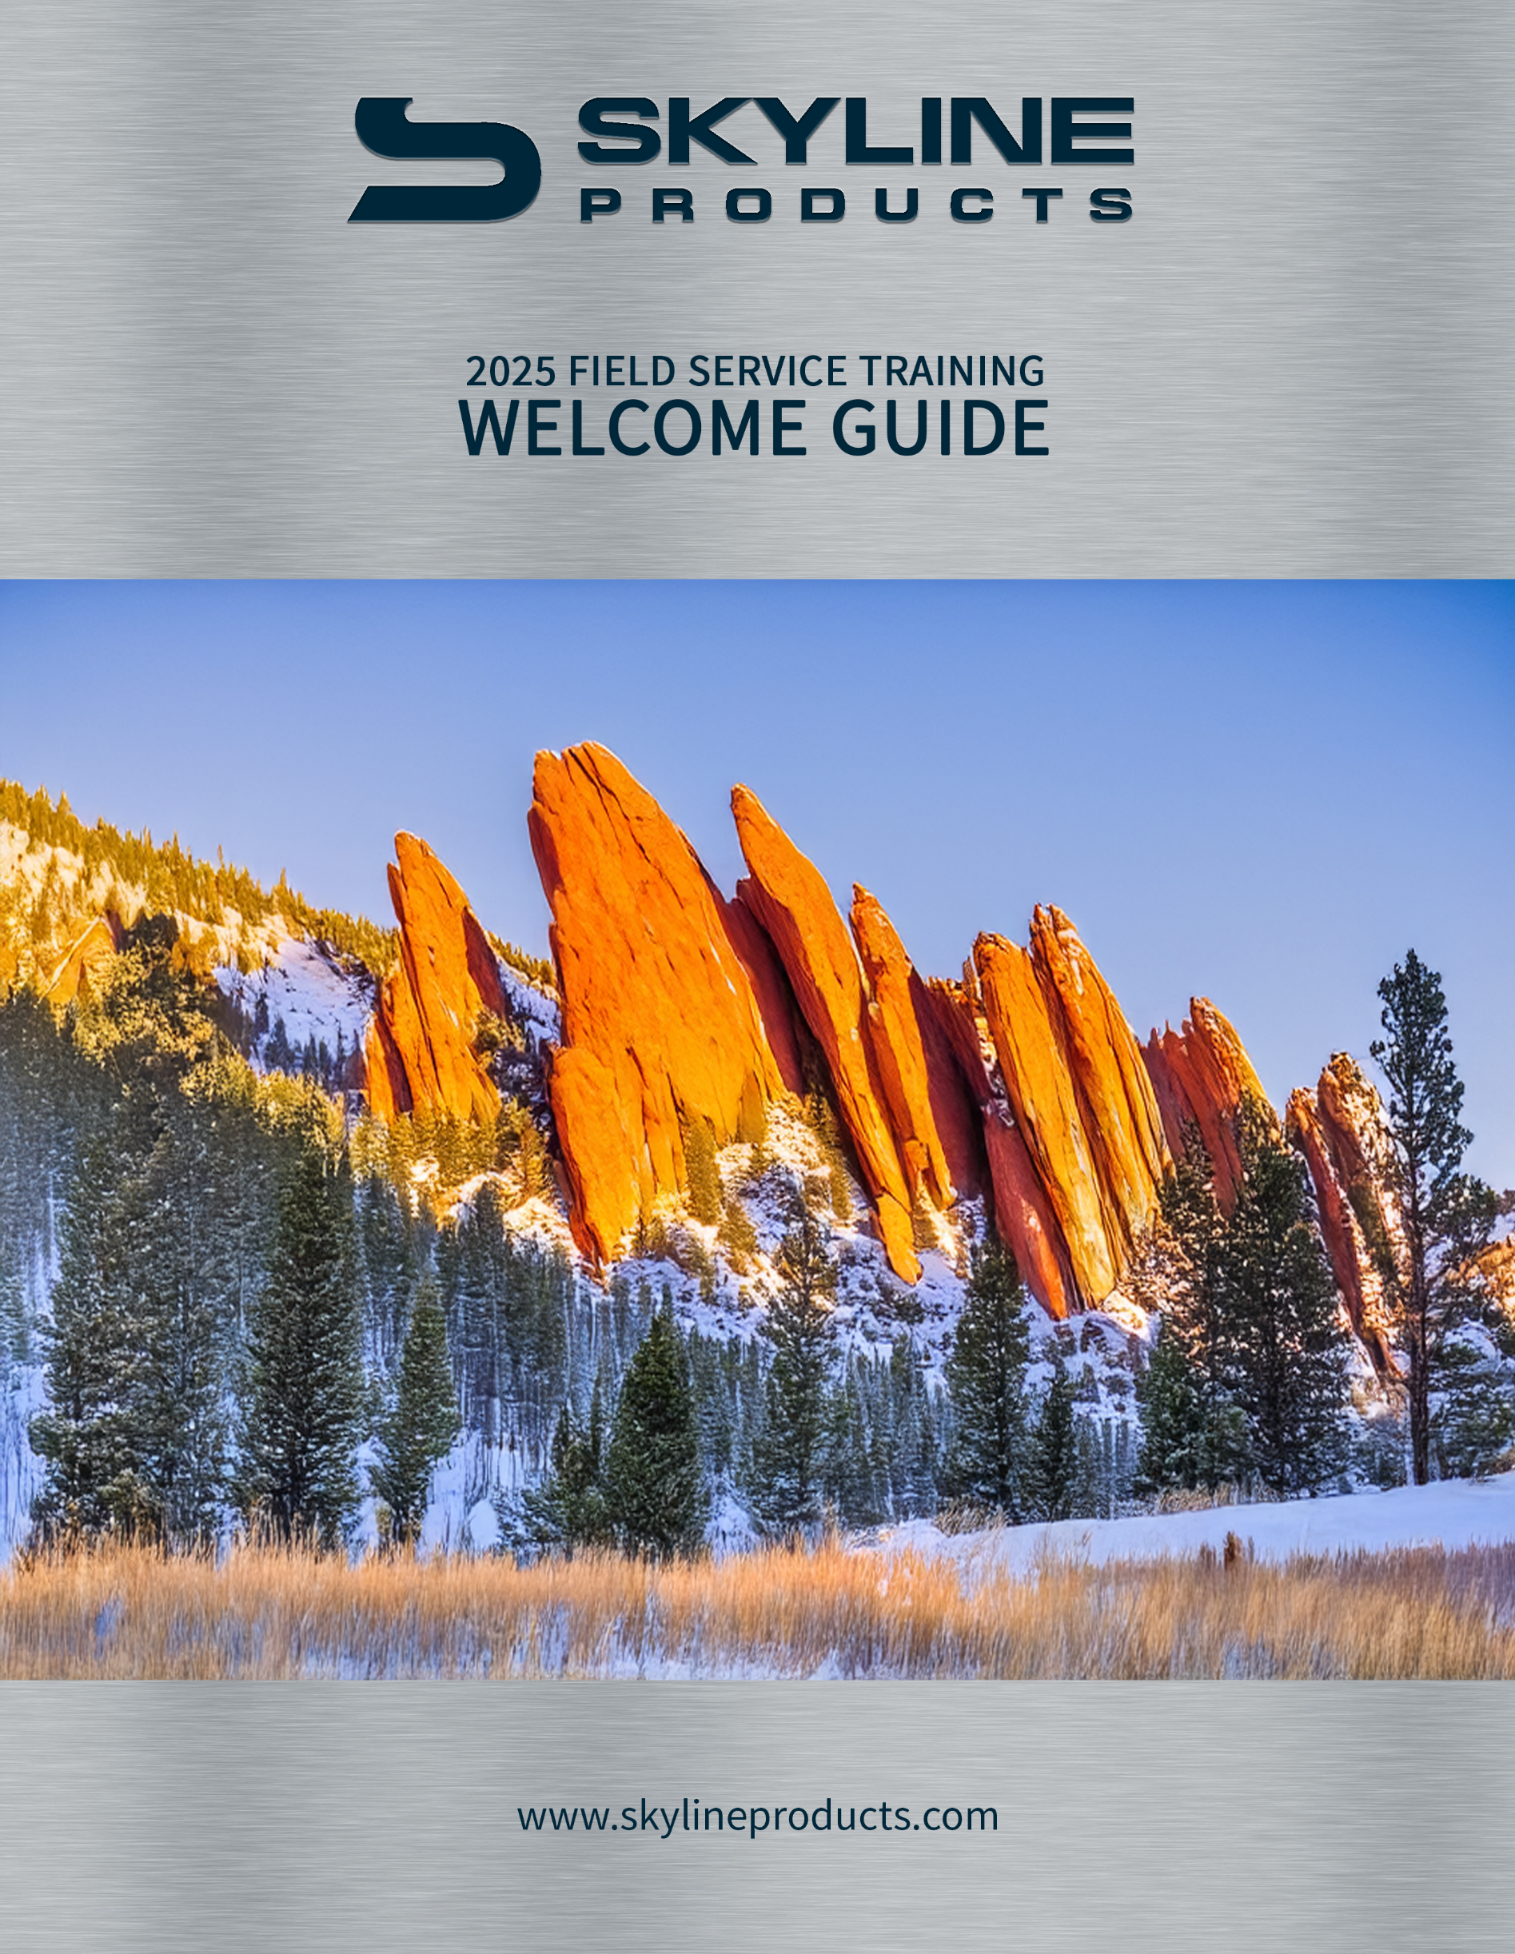

Skyline Products
Field Service Training: Welcome Guide

Welcome to the Skyline Products and PriceAdvantage Training Event!
We are thrilled to have you join us for this hands-on training course. This guide is designed to provide you with all the practical information you need for a smooth and enjoyable stay in Colorado Springs!

Event Details
- Training Location:
Skyline Products, Inc. - Hathaway
707 Hathaway Dr.
Colorado Springs, CO 80915
- Training Hours:
Day 1: 9:00 AM - 5:00 PM (with breaks and lunch provided)
Day 2: 9:00 AM - 5:00 PM (with breaks and lunch provided)
- On-site Amenities:
Complimentary coffee, water, and snacks will be available throughout the day.
Lunch will be provided on both days of the training.

https://maps.app.goo.gl/oME9srJ2LzhunQxE9

Local Information
Note: All distances and drive times listed are from the training location at 707 Hathaway Dr.
https://maps.app.goo.gl/QACv4HVaK5mJHu4TA

Nearby Hotels
The following hotels and motels are conveniently located near the Hathaway training location. We recommend booking in advance.

- Econo Lodge Colorado Springs near Airport
(Approx. 4 miles, 8 min drive)
1520 North Academy Boulevard, Colorado Springs, CO 80909
- Super 8 by Wyndham Colorado Springs Peterson Space Force
(Approx. 3 miles, 7 min drive)
1270 North Academy Boulevard, Colorado Springs, CO 80909
- Travelodge by Wyndham Colorado Springs Airport/Peterson SFB
(Approx. 5 miles, 12 min drive)
6875 Space Village Ave, Colorado Springs, CO 80915

- Fairfield Inn & Suites Colorado Springs East
(Approx. 4.4 miles, 10 min drive)
4107 Tutt Blvd, Colorado Springs, CO 80922
- Hampton Inn & Suites Colorado Springs-I-25 South
(Approx. 10 miles, 15 min drive)
2910 Geyser Dr., Colorado Springs, Colorado, 80906
- The Broadmoor
(Approx. 10.7 miles, 23 min drive)
1 Lake Avenue, Colorado Springs, CO 80906
- Radisson Hotel Colorado Springs Airport
(Approx. 3 miles, 10 min drive)
1645 Newport Rd, Colorado Springs, CO 80916
- SpringHill Suites by Marriott Colorado Springs South
(Approx. 4.5 miles, 12 min drive)
1570 N Newport Rd, Colorado Springs, CO 80916
- Tru by Hilton Colorado Springs Airport
(Approx. 4 miles, 10 min drive)
2845 Zeppelin Road Suite B, Colorado Springs, Colorado, 80916
- Holiday Inn Express & Suites Colorado Springs Airport
(Approx. 5 miles, 12 min drive)
1815 Aeroplaza Dr, Colorado Springs, CO 80916

Transportation
- Colorado Springs Airport (COS)
(Approx. 3.3 miles, 9 min drive)
The closest airport is the Colorado Springs Airport (COS)
7770 Milton E Proby Pkwy, Colorado Springs, CO 80916
- Denver International Airport (DEN)
(Approx. 83 miles, 1 hr 25 min drive)
The Denver International Airport (DEN) is also an option, but is approximately a 1.5-hour drive.
8500 Peña Blvd, Denver, CO 80249
- Ride-Sharing: Uber and Lyft operate throughout Colorado Springs.
- Taxi Services: Local companies like Yellow Cab of Colorado Springs are available.
- Rental Cars: Rental Agencies are available at both airports.

Nearby Restaurants
There are a variety of dining options within a short drive of the training facility.
- The Chuckwagon: (Approx. 1.3 miles, 4 min drive)
6453 Omaha Blvd, Colorado Springs, CO 80915 | (832) 877-0549
- Sandy's Restaurant: (Approx. 2.2 miles, 6 min drive)
6940 Space Village Ave, Colorado Springs, CO 80915 | (719) 204-3723
- Somjai Thai Cuisine: (Approx. 2.4 miles, 6 min drive)
6827 Space Village Ave, Colorado Springs, CO 80915 | (719) 574-6835
- Masala Bites: (Approx. 2.4 miles, 6 min drive)
6829 Space Village Ave, Colorado Springs, CO 80915 | (719) 380-1040
- Osae Sushi Ramen Bistro: (Approx. 2.5 miles, 6 min drive)
1825 Peterson Rd, Colorado Springs, CO 80915 | (719) 570-0543
- Domino's Pizza: (Approx. 2.6 miles, 7 min drive)
6870 Galley Rd, Colorado Springs, CO 80915 | (719) 574-0950
- Dragon King Chinese Kitchen: (Approx. 2.6 miles, 7 min drive)
5825 Galley Rd, Colorado Springs, CO 80915 | (719) 591-6130

Nearby Amenities & Resources
The Hathaway location is situated in the Powers Corridor, a major commercial hub with a wide range of services.
- Shopping: A large Walmart Supercenter (approx. 2.5 miles, 6 min drive) and Walmart Neighborhood Market (approx. 2.6 miles, 6 min drive) are located very close by, providing groceries, pharmacy services, and general retail.
- Peterson Space Force Base: Located just a few minutes’ drive from the training location.
- Sand Creek Golf Course: (Approx. 1 mile, 3 min drive)
This beautiful golf course sits directly between the Hathaway training location and three of the nearby hotels: Econo Lodge, Super 8, and Travelodge.

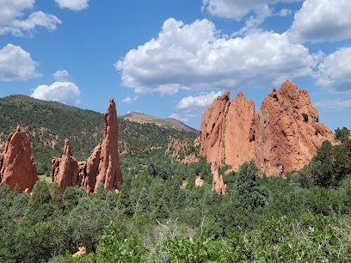
Local Points of Interest
If you have some free time, we encourage you to explore the beauty of Colorado Springs!
- Garden of the Gods: (Approx. 11.3 miles, 24 min drive)
- Pikes Peak: (Approx. 36.3 miles, 1 hr 19 min drive)
- United States Air Force Academy: (Approx. 17.6 miles, 34 min drive)
- Old Colorado City: (Approx. 8.9 miles, 19 min drive)

Exploring Downtown Colorado Springs
Downtown is a vibrant hub of culture, dining, and nightlife. It's an excellent destination for an evening out.

Top 5 Dining Spots:
- The Rabbit Hole: (Approx. 8.5 miles, 18 min drive)
101 N Tejon St, Colorado Springs, CO 80903 | (719) 203-5072
A unique, subterranean restaurant with a creative menu.
- Jax Fish House & Oyster Bar: (Approx. 8.6 miles, 18 min drive)
11 S Tejon St, Colorado Springs, CO 80903 | (719) 357-4554
A popular spot for fresh seafood and cocktails.
- Bingo Burger: (Approx. 8.5 miles, 18 min drive)
132 N Tejon St, Colorado Springs, CO 80903 | (719) 418-6223
A local favorite for gourmet burgers made with fresh, Colorado ingredients.

- Urban Steam Coffee Bar & Cafe: (Approx. 8.3 miles, 17 min drive)
1025 S Sierra Madre St, Colorado Springs, CO 80903 | (719) 473-7832
Known for its eclectic vibe, great coffee, and delicious brunch/lunch.
- Four by Brother Luck: (Approx. 8.5 miles, 18 min drive)
321 N Tejon St, Colorado Springs, CO 80903 | (719) 434-2741
A celebrated restaurant offering a modern twist on American and Southwest cuisine.

Top 5 Bars:
- Tony's Downtown Bar: (Approx. 8.5 miles, 18 min drive)
311 N Tejon St, Colorado Springs, CO 80903 | (719) 228-6566
A classic, laid-back bar with a great selection of drinks.
- Shuga's: (Approx. 8.5 miles, 17 min drive)
702 S Cascade Ave, Colorado Springs, CO 80903 | (719) 328-1412
A cozy cafe by day that transforms into a lively cocktail bar at night.
- The Archives: (Approx. 8.6 miles, 18 min drive)
15 S Tejon St, Colorado Springs, CO 80903
A popular speakeasy with a sophisticated atmosphere and inventive drinks.
- Distillery 291: (Approx. 11.5 miles, 20 min drive)
4242 N Nevada Ave, Colorado Springs, CO 80907 | (719) 323-8010
A local distillery offering tastings of award-winning whiskey.
- Jack Quinn's Irish Pub & Restaurant: (Approx. 8.6 miles, 18 min drive)
21 S Tejon St, Colorado Springs, CO 80903 | (719) 385-0766
A traditional Irish pub with live music and a fun atmosphere.

Top 5 Points of Interest:
- U.S. Olympic & Paralympic Museum: (Approx. 8.3 miles, 17 min drive)
200 S Sierra Madre St, Colorado Springs, CO 80903 | (719) 497-1234
A state-of-the-art museum celebrating the history of the Olympic and Paralympic Games.
- Pioneers Museum: (Approx. 8.6 miles, 18 min drive)
215 S Tejon St, Colorado Springs, CO 80903 | (719) 385-5990
The city's history museum, located in the beautifully restored 1903 El Paso County Courthouse.
- Colorado Springs Fine Arts Center at Colorado College: (Approx. 9 miles, 20 min drive)
30 W Dale St, Colorado Springs, CO 80903 | (719) 634-5581
An art museum, performing arts theatre, and art school all in one.
- Acacia Park: (Approx. 8.7 miles, 19 min drive)
115 E Platte Ave, Colorado Springs, CO 80903
A beautiful public park and a central gathering spot for downtown events.
- America the Beautiful Park: (Approx. 8.5 miles, 18 min drive)
126 Cimino Dr, Colorado Springs, CO 80903 | (719) 385-5940
A large park with fountains and a popular playground, great for an afternoon stroll.

Exploring Manitou Springs

Manitou Springs is a charming, historic town nestled at the base of Pikes Peak, known for its natural mineral springs and unique atmosphere. Manitou Springs is a resort city in Colorado, just outside Colorado Springs. It’s known for its mineral springs and mountain landscapes, dominated by soaring Pikes Peak. The Manitou Cliff Dwellings are a group of reassembled ancient cliff structures. Hundreds of steps lead up a steep slope on the Manitou Incline Trail. Manitou Avenue is home to art galleries and specialty boutiques.
- Sipping Springs: Explore the town's eight natural mineral springs, each with a distinct flavor and believed health benefits. Bring a water bottle to fill up.
- Manitou Cliff Dwellings: (Approx. 12 miles, 25 min drive)
10 Cliff Dwellings Rd, Manitou Springs, CO 80829 | (719) 685-5242
A fascinating look at ancient history with these relocated Anasazi ruins.
- The Incline: (Approx. 12 miles, 25 min drive)
Ruxton Avenue, Manitou Springs, CO 80829 | (719) 633-6884
A challenging but rewarding hike straight up the side of a mountain, offering incredible views.
- Shops & Galleries: The downtown area is filled with unique boutiques, gift shops, and art galleries.
- Dining: Enjoy a meal at one of the many restaurants, from pizza to fine dining, all within a quaint, walkable setting.



